Alaina Saliba
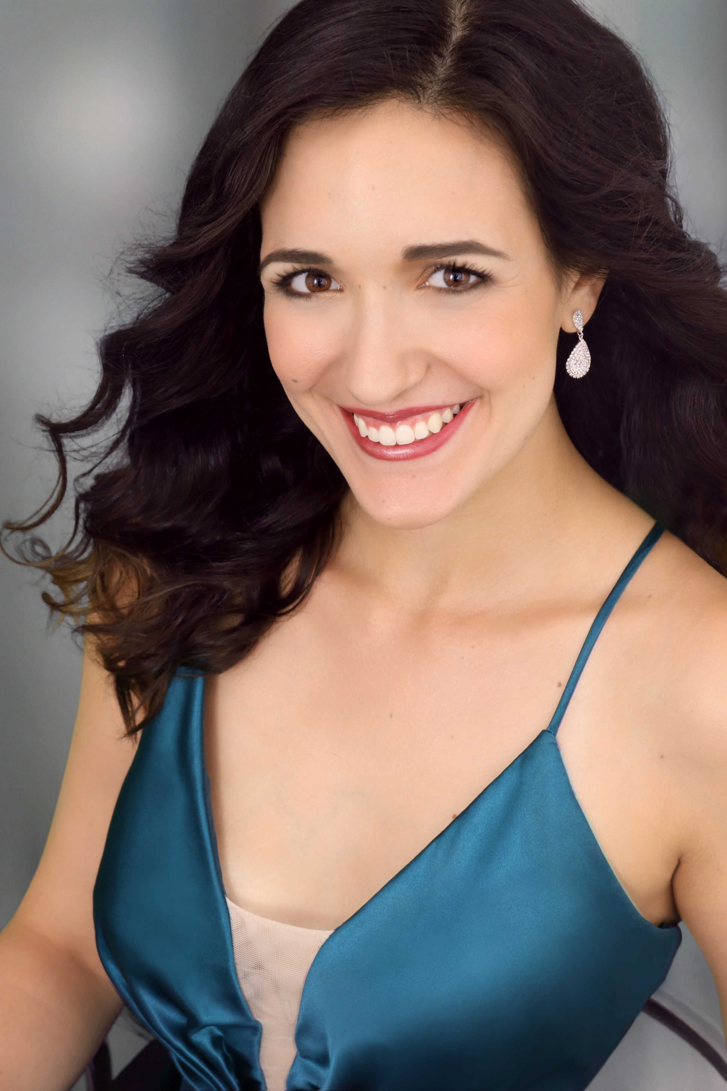
Soprano
4045 N. Emerald Ct. Dayton, OH salibaalaina@gmail.com 937.545.6800 www.alainasaliba.com
Education and Training
Master of Music, Voice | Cleveland Institute of Music | 2022
Bachelor of Music, Music Performance | University of Dayton, Summa Cum Laude | 2020
American Institute of Musical Studies Opera Studio | Graz, Austria | 2019
Dayton Opera Apprentice Program | Dayton, Ohio | 2018
Roles
First Witch* | Dido and Aeneas | Cleveland Institute of Music Opera Theater | 2021
Giulietta^ | I Capuleti e i Montecchi | Cleveland Institute of Music Opera Theater | 2020
Norina^ | Don Pasquale | Cleveland Institute of Music Opera Theater | 2020
Rosina | Il Barbiere di Siviglia | Opera Guild of Dayton | 2020
Velma | Chicago | University of Dayton Opera Workshop | 2020
Meg^ | Little Women (Adamo) | University of Dayton Opera Workshop | 2019
The Princess | The Frog Prince | Dayton Philharmonic Orchestra | 2019
Mabel | The Pirates of Penzance | Opera Guild of Dayton | 2017-2019
Jane | Babes in Toyland | University of Dayton Opera Workshop | 2018
Sandy | Grease | University of Dayton Opera Workshop | 2017
Concert Work
Featured Soloist | Operetta Around the World | AIMS Festival Orchestra, Graz, Austria | 2019
Soprano Soloist | Rutter’s Mass of the Children | Dayton Philharmonic Youth Orchestra | 2019
Soprano Soloist | High Holiday Services | Temple Israel, Dayton, OH | 2019, 2018
Featured Soloist | BRAVO! Fashion Show | Opera Guild of Dayton | 2019
Featured Soloist | Troy Mayor’s Concert | Dayton Philharmonic Concert Band | 2018
Awards
Opera Guild of Dayton Tri-State College Vocal Competition, finalist | 2020
Ohio National Association of Teachers of Singing, first place, Fourth and Fifth Year Classical Treble Voices | 2019
University of Dayton Honors Recital, winner | 2018-20
Kennedy Center American College Theatre Festival, nominee | 2018
Ohio National Association of Teachers of Singing, second place, Second Year Classical Women | 2017

Teachers and Coaches
Dean Southern, Andrea Chenoweth Wells, Elizabeth Hagedorn, Darryl Cooper, Michael Dauphinais
Masterclasses
Caroline Helton, Helene Schneiderman, George Vassos
Directors Conductors
Johnathon Pape, Jerome Yorke Marzio Conti, Neal Gittleman, Patrick Reynolds, David Sievers

